**A screen shot for each year of my results on the Multi Year Stock Data.**

**Year 2014**

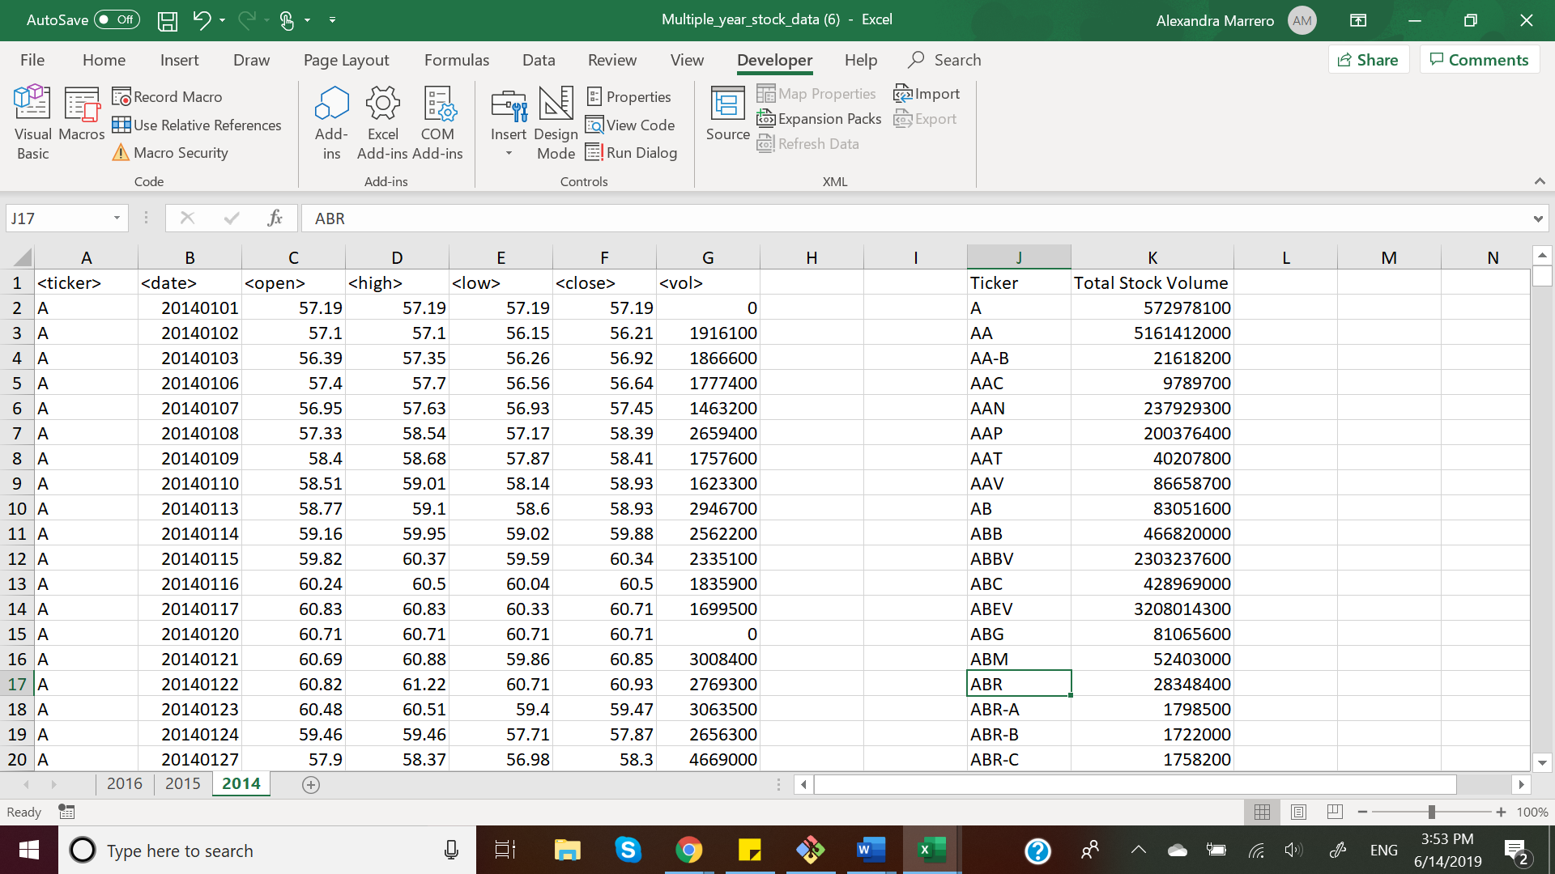

**Year 2015**

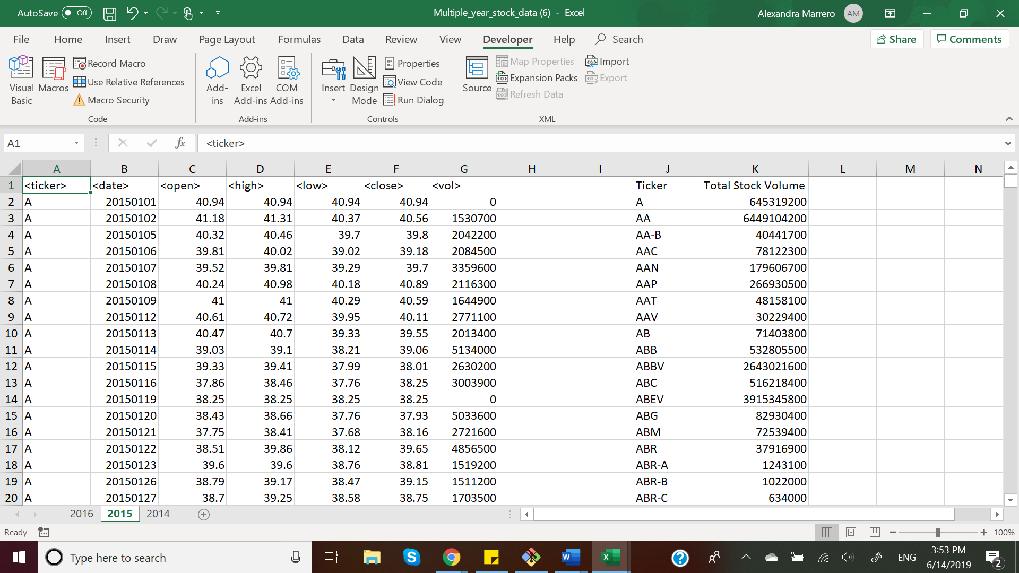

**Year 2016**

